

Vehicle Upload & Bus Captain

Requirement Document

**Version 1.1**

|  |  |
| --- | --- |
| ***Corporate Office & Development Center*** | ***Offshore Development Center*** |
| *1 Pickering Street*  *#06-03 Great Eastern Centre*  *Singapore 048659* | *Plot # 122 & 123, N.S.E.Z, Phase -2*  *NOIDA, UP 201 305*  *India*  *Tel: 91.11.91.2510483* |

|  |  |  |  |  |
| --- | --- | --- | --- | --- |
| **Author** | | | | |
| **Name** | **Role** | **Date of Preparation** | **Signature** | |
| Evelyn Yap | Project manager | 19-Jan-2015 | Evelyn | |
| **Reviewer(s)** | | | | |
| **Name** | **Role** | **Date of Review** | **Signature** | |
| Pravesh Kumar | Manager Projects |  |  | |
|  |  |  |  | |
| **Approver** | | | | |
| **Name** | **Role** | **Date of Approval** | **Signature** | |
| ChengChoon Yip | VP Ebix Exchange  Asia |  |  | |
| **Document Path** | **Version Number** | **Date of Release** | | |
|  | 1.00 | 19-Jan-2015 | | |
| **Revision History** | | | | |
| **Version Number** | **Date of Release** | **Section/ Page # Changed** | | **Details of Changes** |
| 1.00 | 17-Feb-2015 | All | | Document created |
| 1.1 | 5-Mar-2015 | 5,6,7 | | New Changes and Requirements |
| 1.2 | 24-Mar-15 | 6,8 | | New Changes highlighted in Yellow. |

|  |  |  |
| --- | --- | --- |
| **References** | | |
| **Document** | **Date Received** | **Author** |
|  |  |  |

Contents

2. Overview 4

a. Module 4

b. Development Type 4

3. Vehicle Upload 4

3.1 Changes Required 4

3.2 Search Functionality 5

3.3 Vehicle Display Results 5

3.4 Mapping 5

4. Bus Captain Upload (Still In Discussion With CDGI) 6

4.1 Changes Required 6

4.2 Mapping 6

5. Rule 6

6. Implementation 6

6.1 Current Implementation 6

6.2 Targeted Implementation 6

7. Change Required 6

# Overview

|  |  |  |  |
| --- | --- | --- | --- |
| ☒ | New | ☐ | Change Request |

* 1. Module

|  |  |  |  |  |  |
| --- | --- | --- | --- | --- | --- |
| ☐ | Diary | ☒ | System Admin Module | ☐ | Claim Registration |
| ☐ | Claim Payment | ☐ | Claim Recovery | ☐ | Claim Enquiry |
| ☐ | Upload | ☐ | Reports |  |  |

* 1. Development Type

|  |  |  |  |  |  |
| --- | --- | --- | --- | --- | --- |
| ☒ | Functionality | ☒ | Integration | ☐ | Rule |
| ☐ | Report | ☒ | Field | ☒ | Screen |

# Vehicle Upload

## 3.1 Changes Required

1. On top of the current upload results, system needs to show all the entries uploaded from the Vehicle Upload File.
2. System is to capture only these fields from the Excel File:
   1. Bus No.
   2. Chasis No
   3. Make
   4. Model
   5. Type
   6. Aircon
   7. Axel

**Validation:**

1) System needs to validate that the Make and Model exists in the Vehicle Make and Vehicle Model Menus during the upload of the Excel File. If the Make and Model do not match the ones in the Master Table, System will mark the entry as failed.

2) If there are same make and model across multiple Vehicle Classes, system will still match accordingly. As long as there is a match, system will proceed and the Vehicle Class will also be inserted into the uploaded entry.

1. Allow Users to add New Vehicle and fields are as per Point #2.

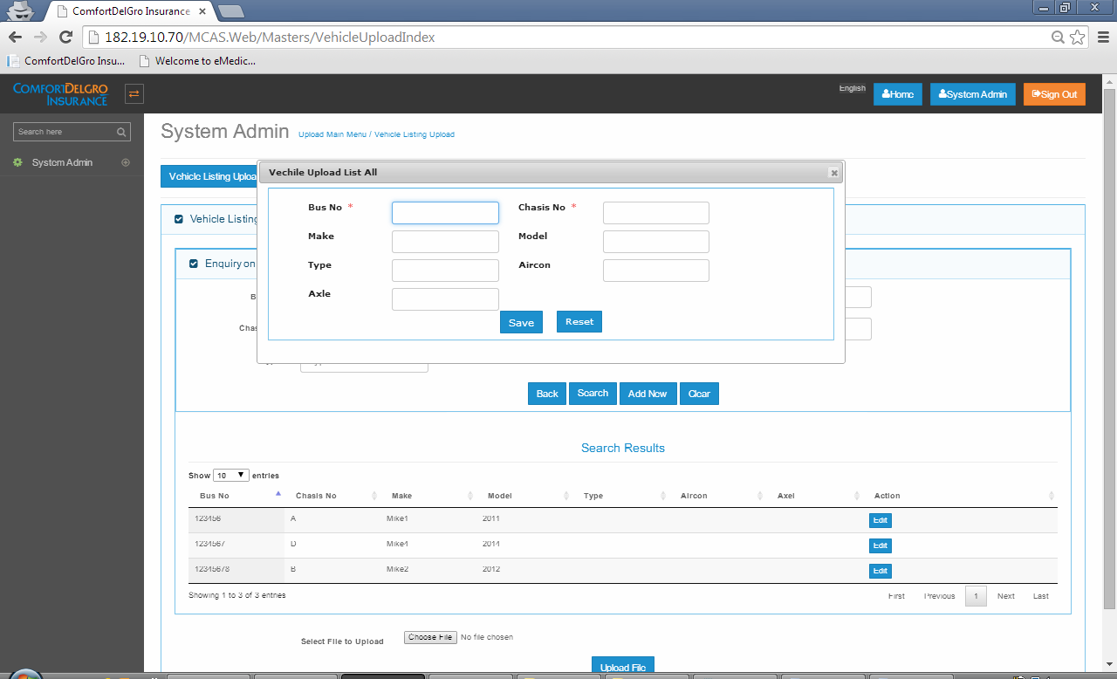

**Changes: Add one new field “Vehicle Class” and populate the values from the Vehicle Class Master Table. Selecting the Vehicle Class will show the list of values for the Make and Model for the users to select. Therefor the current Text Box for the Make and Model needs to be changed to a Drop Down Field.**

**Changes (24/3/2015-#1): Include a Drop Down Field in the Upload File Section, beside “Select File to Upload” and label this Field as “Select Vehicle Class To Validate”. System will show a list of Vehicle Class created in the Vehicle Class Masters. Upon clicking on the Upload File Button, System will validate all the corresponding Make and Model with the related Vehicle Make and Vehicle Model Masters. System will include the chosen Vehicle Class in the entries after successful uploads.**

**Changes (24/3/2015-#2): System needs to show Successful, Failed Records and LOG File in a separate Tab like what we have in the File Upload Section.**

**Changes (24/3/2015-#3): Change the Add New Popup Screen to a New Window Screen like the one from Bus Captain Listing. We need to standardize all the Add New Screens with a New Window. Having Pop-ups will create issues when users’ browsers prevent pop-ups from showing.**

1. Uploaded Results can be edited by Users.

## 3.2 Search Functionality

Fields Include:

* Bus No.
* Chasis No.
* Class
* Make
* Model
* Type

## 

## Vehicle Display Results

|  |  |  |  |  |  |  |  |
| --- | --- | --- | --- | --- | --- | --- | --- |
| Bus No | Chasis No | Class | Make | Model | Type | Aircon | Axel |
|  |  |  |  |  |  |  |  |
|  |  |  |  |  |  |  |  |

## Mapping

When Claim File Upload is uploaded to the System, System needs to map the Vehicle Number Value to the Master Table in the Vehicle Upload and populate the Make and Model Fields in the Accident Screen.

If System is unable to match any Vehicle Number in the Master Table, system will leave the Make and Model Fields empty.

# Bus Captain Upload (Still In Discussion With CDGI)

## Changes Required

* Same as Vehicle Upload Screens, System allows User to allow Excel File to upload Bus Captain Listings.
* Include Upload Results Section which Vehicle Upload is currently having
* Excel File will include Bus Captain Code, Name, NRIC/Passport Number, Contact Number and Nationality
* Currently Bus Captain Code is generated by System, this needs to be removed
* Under Add New Screen, include Bus Captain Code Field and make it compulsory.
* Uploaded Results can be edited by User

**Changes (24/3/2015-#1): Make these fields Mandatory: Bus Captain Name, NRIC/Passport No., and Nationality.**

**Changes (24/3/2015-#2): Bus Captain File is still not ready but for upload process, we need to show Success, Failed and LOG File Records in a new Window.**

## Mapping

* When Claim File is uploaded, System needs to match the Bus Captain Code in the Master Table and populate the Name, NRIC/Passport Number and Contact Number in the Accident Screen.

# Rule

|  |  |  |  |  |
| --- | --- | --- | --- | --- |
| IF | Then | Else | And | Or |
|  |  |  |  |  |
|  |  |  |  |  |

# Implementation

## Current Implementation

## Targeted Implementation

# Change Required